Tom Quilty Gold Cup 2017

Biosecurity plan

Date first arrival: Monday 3rd July 2017
Date last departure: Monday 10th July 2017

Location: Wirrina Cove, South Australia

Proposed: 9th of February 2017
Accepted:
Event Organizer  Event Director  Contact details | South Australian Endurance Riders Association Inc. and SA Tom Quilty Inc.(SATQ), the Organising Committee (OC)  Jean Sims  Phone Number: 0429781004  Email: ina.jean.sims@gmail.com
Event Biosecurity Manager  Contact details | Name:  Phone Number:  Email:

This Biosecurity Plan outlines a set of preventative control measures and actions aimed at reducing the risk and spread of an infectious diseases outbreak affecting people and horses on and off the Tom Quilty event venue. Every individual has a responsibility to abide by the biosecurity measures and to follow the directions of the Organising Committee (OC) or risk expulsion from the event.
This document applies to management of infectious disease risk generally, which could include strangles, diarrhoea and respiratory illness and includes information relating specifically to Hendra virus risk. Biosecurity also includes management of risk associated with livestock pests such as cattle ticks.

Infection with Hendra virus carries significant human health implications and vaccination of horses against Hendra is encouraged. Vaccination provides the single most effective means of reducing the risk of Hendra virus infection in both horses and humans.

The Event Biosecurity Manager must be advised if there is a horse health issue prior to the Head Veterinarian’s arrival and is in charge should a biosecurity risk arise before the Head Veterinarian arrives on site.

Management of biosecurity risk will be in accordance with the policy and advice of the South Australian DEWNR. A variety of policies and guidance is available on the DEWNR website.
EMERGENCY CONTACT LIST

ORGANISATION | NAME | PHONE  NUMBER | COMMENT
Emergency Animal  Disease Watch Hotline |  | 1800 675 888
Biosecurity SA PIRSA | Animal Services  Emergency Hotline  Office hours | 1800 675 888  08 8207 7847
Biosecurity Manager | Dr
TQ2017 Ride Director | Jean Sims | 0429781004 | ina.jean.sims@gmail.com
Head Veterinarian | Dr Lidwien Verdegaal | 0467817839 | LidwienVerdegaal@hotmail.com
Head Chief Steward | Gerard Bou | 0407478929 | gahjpb@hotmail.com
Treatment Veterinarian | Dr Robyn Mather | 0418876848 | robynmather@bigpond.com
Equine referral hospitals | 1. Morphetville Equine Clinic, 90 Morphett Rd Glengowrie SA 5044  2. Equine Health and Performance Centre (EHPC), University of Adelaide, Roseworthy campus, Mudla Wirra Rd, Roseworthy | 1. 08 82948900  2. 08 8313 1977 | horsemedsa.com
Venue Owner/Manager | Ben and Holly Taylor | 8598 3125  0419 808 492  0438 427 796 | PIC: SB472288  Number of exit and entry points:  1main of each (3 emergency exit)
Neighbours with horses | Phillip Reid | 0408 856 074 | Next door North of park
Local Police | Normanville Police Station | 8558 2014 | 2 Mary Ave Normanville
Workplace Health Safety  (SA details) | Safe work SA | Help Centre  1300 365 255 | 24/7 emergency  1800 777 209
Ride Base doctor | Andrew Luck
Local hospital | South Coast District Hospital, 56 Bay Rd, Victor Harbour 5211 | 85520500 | 24/7

The objectives of this Biosecurity Plan are to:
1. Prevent or minimise the risk of equine infectious disease arriving at the event venue.
2. Prevent the spread of equine infectious disease amongst participants, should illness appear.
3. Protect the health of all participants, horse and human.
4. Present biosecurity measures that are guided by government policy and which will present least impediment to the event.

This Biosecurity Plan applies the known science to identify risk of infectious disease and appropriate management actions to reduce this risk to people and horses. Where scientific knowledge is uncertain, a precautionary risk management approach will be taken.
Actions will be applied at the ride venue, but also before horses arrive at the event, focusing on movement of horses on and off the event venue, identification of horses and people, hygiene of horses, people, vehicles and equipment, provision of appropriate horse health care, record keeping and provision of information. The Biosecurity Plan contains information and guidance for all participants, including event organisers, competitors and volunteers.

It must be noted that the person responsible for each horse is ultimately responsible for ensuring that their horse does not pose a risk to the health of horses or people at the event. Every participant has a responsibility to abide by the biosecurity measures and to follow the directions of the Biosecurity manager, Organising Committee (OC), Chief Steward and Head Veterinarian. Failure to do so risks exclusion from the event.

Participants must check with their relevant State or Territory Government regarding legislative requirements such as waybills, travel permits, fodder declarations, and cattle tick movement regulations.

Overseas participants must familiarise themselves, and comply with, the applicable Australian quarantine requirements. Information about traveling to Australia can be found at
http://agriculture.gov.au/travelling/to-australia/

Table of Contents
BIOSECURITY POLICY INTRODUCTION ………………………………………………………………………………………………….. 6
1. RESPONSIBILITIES OF PEOPLE IN CHARGE OF THE HORSE ……………………..…………………………………….…… 9
(i). PREVENTING THE INTRODUCTION OF DISEASE ONTO THE RIDE VENUE: .…………………………………… 9
- OWNER AND HORSE INFORMATION .………… 9
- HYGIENE 9
(ii) PREVENTING THE SPREAD OF DISEASE AT THE RIDE VENUE: 10
- INFORMATION AND HORSE HEALTH 10
B. HYGIENE .…………………………………………………………………………………………………………………………………… 11
C. FINANCIAL RESPONSIBILITY ………………………………………………………………………………………………………... 11
D. BIOSECURITY INCIDENT RESPONSE …………………………………………………………………………………………….. 11
Appendix 1 (1a) the Notification of Veterinary Advice for Equestrian Events, ……………………………………. 14 Appendix 1 (1b) Hendra and Conjoined Zones by Local Government Area……………………………………………18
Appendix 2 – 10 Day TQ17 Temperature log and Horse Health Declaration ………………………………………… 20
Appendix 3 – TQ17 Quarantine declaration incl. declaration of the location ……………………………………….23
Appendix 4 - 28 day TQ17 Quarantine Temperature Log ….………………………………………………………………….. 25
Appendix 5 - Site map ………………………………………………………….………………………………………………………………. 26
Appendix 6 - Emergency contact list ……………………………………………………………………………………………………. 27
Appendix 7 - List of definitions ……………………………………………………………………………………………………………. 28

BIOSECURITY POLICY INTRODUCTION
Biosecurity is the management of infectious diseases to reduce the risk of transmission to the minimum with a comprehensive approach. The critical elements are the control of disease agents and the prevention of the spread of any disease agents.
This includes hygiene practices and the quarantine of, and control of infectious diseases onto and within an endurance ride venue and surrounding roads and tracks. This information applies to management of infectious disease risk in general (such as strangles and other respiratory illness, diarrhoea, etc.) and includes information specifically relating to Hendra virus risk and its’ zoonotic potential. While this document is not specifically related to Hendra virus and associated outbreaks, it is important to note that the vaccination of horses in relation to the Hendra virus is recognised as the single most effective way to prevent Hendra infection. Vaccination provides a public health, workplace health and safety benefit. Vaccinating horses is an important measure to prevent human infection. The vaccine is a fully registered product and considered safe for use in horses. The responsibility to respond accordingly is heightened by the fact that vaccination as a risk prevention measure is extremely effective, accessible and affordable. Equine Veterinarian Association (EVA) is in complete agreement with these ratings and advises that vaccination is a reasonably practicable risk mitigation strategy by any standard. EVA advises that Hendra virus risk at equestrian events is extremely difficult to manage and requires vaccination (Appendix 1a).
Competitors will be advised before and during the event that:
- They have a biosecurity obligation to take all reasonable steps to ensure their activities do not spread a pest, disease or contaminant.
- Horse Health Declarations (HHD) and the Temperature Log Duration are a mandatory requirement and must be completed by the person responsible for the horse.
- The property identification code (PIC) of the horse’s origin and returning property must be included on the HHD.
- Acceptance into the event will be refused if the required HHD is not presented at point of entry or designated registration point.
- No horses with signs of illness are to be brought onto the grounds.
- Direct nose to nose contact between horses should be minimised.
- Biosecurity equipment should be available at all times.
- Competitors are responsible for cleaning up manure from yards and placing it in designated areas.
- Competitors are required to advise the event organisers immediately if a horse is sick, to stop all non-essential contact with the sick horse and not allow children to have close contact with the sick horse.
The temperature log duration for a horse not from a Hendra Risk Zone or a vaccinated horse in the Hendra Risk Zones (as identified in the AERA biosecurity policy appendix 1b) Extension Zone is 10 days. For an unvaccinated horse from a Hendra Risk Zone coming to TQ17 the temperature log needs to be of 28 days duration, starting from the date the horse arrived at the quarantine location outside of the known Hendra risk zone.
Horse Health Declarations should be honest, accurate and reliable; they will be collected at the designated point of entry to the ride base. The entrance road to the Ride Base At Wirrina Cove Holiday Park has limited width for 2 way traffic. Therefore, in the interests of Horse welfare and Vehicle safety, the ROC has decided that the BioSecurity Gate will be located at the Yankalilla Showgrounds, Main Street, Yankalilla. This is about 15km north of the actual Wirrina Cove Ride Base. It is passed by all incoming traffic. Access is off a straight road through a wide gate on the right hand side. This will be well sign posted. There is ample flat open ground for floats and goosenecks to pull up and queue if necessary. A Vet, TPR and ROC delegate will be on duty to receive and check all paperwork. Horses must unload and be TPR’d and given the ‘all clear’ by the Vet. Drivers will then be given a windscreen sticker to show they have cleared the Bio Security Check. They can then reload and drive forward out the Showgrounds Exit gate and continue the journey to Wirrina Cove Holiday Park.
Our Camp Bosses at the Ride Base gate will meet and escort you to your designated Campsite. This should negate any unnecessary queuing and waiting at the Ride base entry. The TQ17 ROC ask that all visitors respect our Bio Security Policy and help to make this a smooth process by assisting our Officials at the Showgrounds.
If your horse transport vehicle does not display a BioSecurity Sticker you will not be allowed access to the Ride Base.
Vehicles without horses may travel directly to Wirrina Cove Holiday Park and will be directed to their campsite.

In addition, competitors from the high Hendra risk areas need to be advised that:
- SAERA proposed that all horses attending TQ17, whose property of origin lies within a known Hendra risk area as identified in appendix 1b, present at the event with a current Hendra vaccination certificate, in addition to any other biosecurity measures which will form part of the TQ17 biosecurity document.

- Nevertheless, AERA’s advice is to install a quarantine period for non-vaccinated horses originating from higher Hendra risk areas.

- TQ17 has widened the Hendra risk zone to match the AERA biosecurity plan, please see appendix 1b. If you choose not to vaccinate and to undergo quarantine at a property outside of the known Hendra risk zone, the TQ17 committee needs to be informed of your intentions before the 7th of May 2017 and the quarantine period will be 28 days BEFORE initiating travel. Temperature log registration by taking the rectal temperature in the morning, needs to continue until arrival at the event. The quarantine period also includes registration of abnormal clinical signs and a 15 metre clearance distance from other horses.
For example, if a chosen quarantine location is 2 days travel from the horse usual place of residence, quarantine is not considered to have commenced until arrival at that destination.
Further requirements from the high Hendra risk areas horse owners who elect to undergo quarantine include:
- Provide identification details including microchip number of the horse/s, details of the quarantine property and contact phone numbers and names of person/s in charge of the horse/s at any/all stages, to enable access when requested as described in Appendix 3.The TQ17 committee and or its delegates will take the opportunity to perform random checks at quarantine locations.
- Provide a signature on provided declaration of the location, their general itinerary (travel plan) including time and location before leaving home (Appendix 5) and 28 day quarantine period (Appendix 4)

In summary competitors need :

If travelling from a non-Hendra risk area:
- 10 day Horse Health Declaration and temperature log (Appendix 2)

If travelling from a Hendra risk area and the horse/s is/are not HEV vaccinated:
- TQ17 Quarantine declaration including declaration of the location (Appendix 4)
- 28 day TQ17 Quarantine Temperature Log commencing the day the horse/s arrive at the quarantine location outside of the Hendra risk zone (Appendix 5)
- TQ17 committee needs to be informed of your intentions before the 5th of May 2017

If travelling from a Hendra risk area and HEV vaccinated
- Current vaccination certificate
- 10 day Horse Health Declaration and temperature log (Appendix 2)

Please review the following appendices:

Appendix 1a - The Notification of Veterinary Advice for Equestrian Events (http://www.ava.com.au/sites/default/files/EVA%20website/ResourcesDownloads/Notification%20of%20Veterinary%20Advice%20for%20Equestrian%20Events.pdf)
- Relative to Hendra virus for the purposes of this document it is considered essential to identify zones where Hendra risk to Horses is higher.
Appendix 1b - The identification of local government areas where there has been a known Hendra incident. Recognizing that there should also be a buffer zone to allow for Hendra incident movement, the appendix also includes all government areas conjoining those listed. Hendra incidence areas and conjoining areas together form the Hendra Risk Zone referred to where necessary in this document. All other states and territories at the time of the compilation of this document are free of the Hendra virus.
Appendix 2 – The 10 day Horse Health Declaration and temperature log
A Horse Health Declaration (See Appendix) must be completed prior to entry to the venue and will detail the contact details of the owner or person in charge of the horse, the address and PIC number of the horse's property of origin immediately prior to travel, a temperature log, a horse health declaration by the owner or person in charge of the horse(s), and a declaration.
Appendix 3 – 28 day TQ17 Quarantine Temperature Log
Appendix 4 - TQ17 Quarantine declaration including declaration of the location
The management of infectious diseases requires the fulfilment of certain obligations prior to the ride and at the ride by people in charge of a horse, on the one hand, and by ride organisers on the other.

1. RESPONSIBILITIES OF PEOPLE IN CHARGE OF THE HORSE

(i). PREVENTING THE INTRODUCTION OF DISEASE ONTO THE RIDE VENUE

All people who bring horses or livestock onto the grounds are expected to be aware of their biosecurity obligation that they must take all reasonable steps to ensure their activities do not spread a disease or contaminant.
All horses entering grounds must be from a property actively practicing good biosecurity principles within their management.

The following actions are required of the person responsible for each horse.
A. OWNER AND HORSE INFORMATION
Provide the ride secretary with:
- Name and contact details of the person (including any changes before the horse arrives) who is responsible for each horse when finalising entries
Horse health declaration (Appendix 2 and 3) should include full details of your horse/s identity and property of origin, including PIC on arrival at the ride venue. The declaration includes a temperature log for the number of 10 days or 28 days prior to arrival at the ride venue and subsequently, until the pre ride veterinary check. Health checks should include: normal eating and drinking habits and temperatures between 37.5°C - 38.5°C. Any nasal discharge, coughing, fever (temperature higher than 38.5°C for more than 12-24 hours), swelling of lymph nodes, lameness or off food or water should be noted and a veterinarian contacted to conduct an examination. DO NOT bring an unwell horse onto the ride base. If the horse is suspected of a communicable disease, based on the information received and or from the visual clinical signs presented by the horse, the clinical exam should be carried out within the Isolation area out side of the event base. A rectal temperature is required after unloading the horse if safe to do so. Fractious horses or stallions can be the exception. Based on these clinical findings, the decision may be made to enter the hospital area or to examine the horse within the isolation area.
Horses suspected of potential contagious disease will be refused to entry to the event.
The attending person is responsible for cleaning and ensuring that any contagious (e.g. faecal) material is promptly removed from the ground and appropriately disposed of.
- If a horse becomes unwell while travelling, contact a vet and the ride organiser, before arrival at the ride base
- Proof of current vaccination if your horse/s is/are vaccinated against Hendra virus. Accepted proof is a vaccination certificate or notation in the horse/s’ logbook completed by the vet who administered the vaccine or scanned microchip by the Chief Steward, Biosecurity Manager, or Head Vet and compliant in the Hendra Vaccine registry https://health4horses.com.au/About/Hendra-Vaccination-Lookup/

B. HYGIENE
- Wash your horse/s before leaving home so that soil and organic matter are removed from their coats and hooves
- Check for any evidence of ticks and abide by all government regulations for spraying
- Wash your vehicles and floats before leaving home to remove visible dirt
- Clean all horse gear of visible dirt before leaving home
- Bring sufficient tack, feed and water containers with you, to avoid sharing these at the event
- Adhere to all regulations regarding the transport of plants (including horse feed) and animals, which apply to your point of origin. International competitors must comply with Australian quarantine regulations

(ii) PREVENTING THE SPREAD OF DISEASE AT THE RIDE VENUE

The following actions are required of the person responsible for each horse.
A. INFORMATION AND HORSE HEALTH
- At the gate, the person responsible for the horse will be asked to provide a fully completed temperature log for each horse entered in the ride and its travelling companions Your horse(s) may be required to be identified for the duration of the event by a number written in crayon on the rump. Numbers can be rewritten if they become illegible. The RO/Chief Steward is responsible for this
- Take your horse/s rectal temperature every morning from arrival at the ride venue until the pre ride vet check, and during ride vet checks if required
- Immediately notify the Chief Steward/Head Vet /or Treatment vet if your horse becomes unwell during the event
- Horses, which are not currently vaccinated against Hendra virus, from a high Hendra risk zone are identified by a ribbon in their mane for the duration of the event. The event organisers will provide the ribbon

Veterinary Treatment Hospital and Isolation Zone
- Treating Hendra unvaccinated horses from Hendra risk areas: invasive procedures such as stomach tubing, rectal exams and administration of iv fluids might be conducted with appropriate PPE and the person in charge of the horse shall be responsible for payment of these costs.
- Prior to the event, the Biosecurity Manager and Organising Committee will identify and mark off an agreed isolation zone with hazard tape, a minimal 15 metre to horses or other people.

The Biosecurity Manager, in consultation with the Organising Committee, is in charge should a biosecurity risk arise. While the Biosecurity Manager does not possess the legal powers necessary to quarantine or restrict movements of people, they will arrange to have the details of any person and/or animal leaving the grounds if they have been directed not to.

B. HYGIENE
As much as possible, minimise contact with other people’s horses, and restrict access to your horse/s by others, in particular other people’s horses.
- Clean your horse yards of manure and feed scraps on a regular basis
- A PPE KIT with mask, gloves, overalls & goggles will be held on grounds
- Collect manure so it can be easily removed from your camp by the event organisers

C. FINANCIAL RESPONSIBILITY
Please note that the person responsible for any horse requiring treatment, including sampling and laboratory testing, will be responsible for all costs associated with treatment, including all PPE gear used. Horses’ logbooks will not be returned while accounts remain outstanding.

D. BIOSECURITY INCIDENT CONTINGENCY PLAN
In the event that a sick horse is confirmed at the event, the following plan is to be followed:
Sick horse
- Organising Committee and Biosecurity Manager are to be advised of a sick horse immediately.
- Biosecurity Manager will contact the Head vet.
- Horse is to be taken to isolation area, via the most direct route avoiding any unnecessary contact with other people or horses until review by the vet.
Vet attendance
- If the Head or treating vet declines to attend to a non-Hendra vaccinated horse, the owner will be required to organise for their own treating vet, and if able to travel, leave the venue.
- If the horse is unable to travel, a vet may decide to perform a Hendra virus exclusion test and the horse will remain in isolation until the test results are available.
- If the horse is deemed to be non-infectious, it may be returned to regular stable and will be managed by owner/ exhibitor and attending vet (at owner's expense).
- OR -
- If the horse is diagnosed as being a possible biosecurity threat, it is to remain in isolation zone with a minimum 15 -metre to other horses or passing people.
- Biosecurity Manager will contact Emergency Disease watch hotline for South Australia.
- All people within the isolation zone i.e. vet, officials, owner, are to don PPE gear when tending to horse.
- Disinfection of shoes via footbaths and strict hand hygiene to be followed.
- Hendra specific protocol (next page):

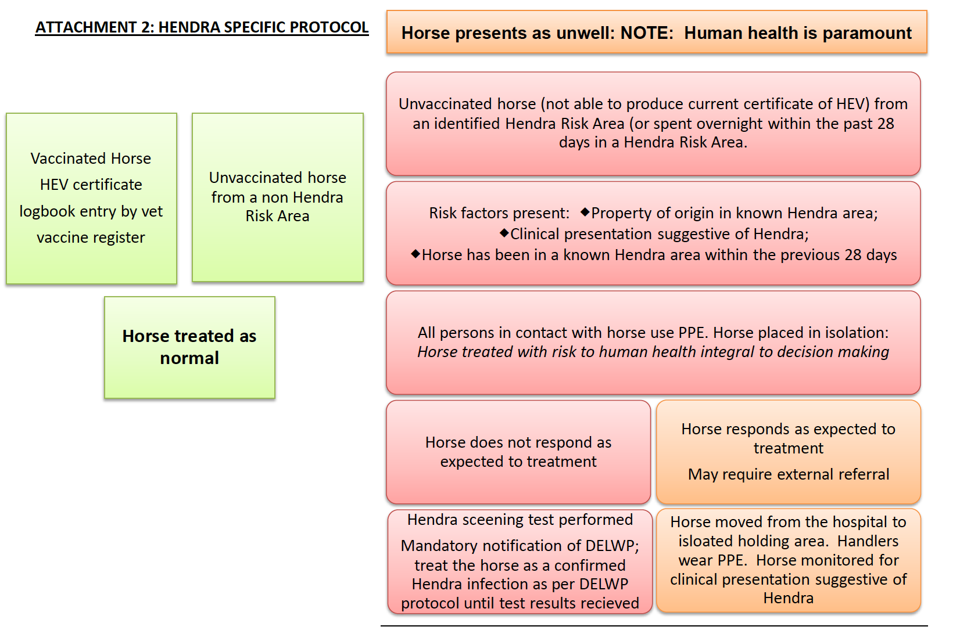
appropriate

Contact Emergency Animal Disease Watch Hotline: 1800 675 888 (available 24 hours) OR Biosecurity South Australia (08) 8207 7872

Further information
http://www.ava.com.au/sites/default/files/TheHendraVaccine-YourQuestionsAnswered-WebVersionMay2015.pdf

Biosecurity issue Identified
- Biosecurity Manager in conjunction with attending vet will contact the Biosecurity authority for the state involved.
- Biosecurity Manager will ask OC to close exit points and broadcast to all present at the venue to remain on site until further information and exit points are closed.
- Event organiser will take advice about whether to continue with the event, after discussion with the Biosecurity authority of the state involved, and advise participants of this decision.
- Horse Health Declarations for all horses on site are made available to the Biosecurity authority of the state involved.
- Access to isolation area will be patrolled by the Biosecurity Manager and limited to essential personnel.
- All horse movement to cease unless authorised by the Biosecurity authority of the state involved.

Lockdown
- The Biosecurity authority of South Australia involved, will advise if a total lockdown of the venue is required and the event organising committee will advise participants of this decision. The advise of the South Australian authority will be the final decision and will be followed by the organising committee.
- All participants/entrants will be responsible for their own costs in the event of a lockdown.
- The Biosecurity Manager will regularly check entry/exit points to ensure anyone leaving the venue is given an exit notice and their vehicle registration is noted.
- The Biosecurity Manager will make arrangements for waste removal if required.
- The Biosecurity authority of the state involved will advise the Biosecurity Manager and participants of any further protocols required.

Appendix 1a Notification of Veterinary Advice for Equestrian Events
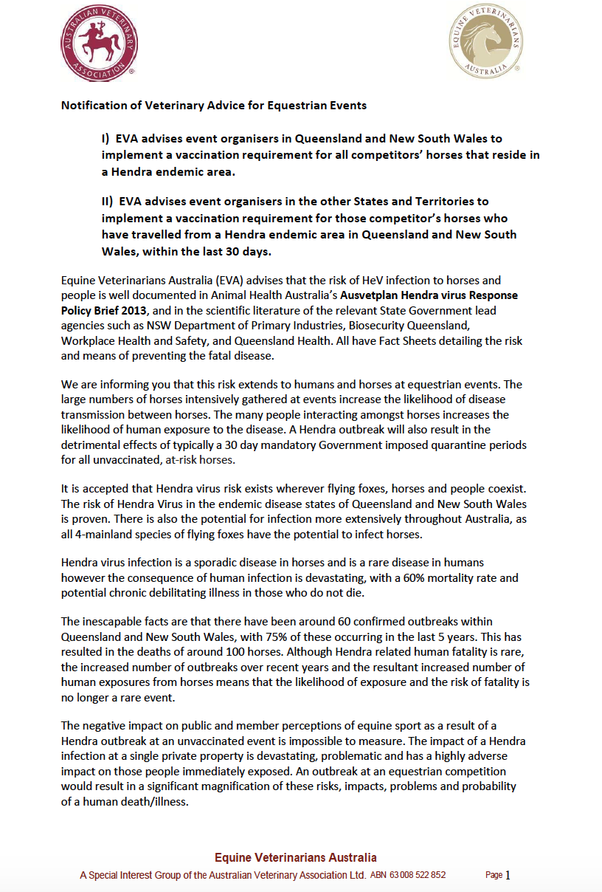
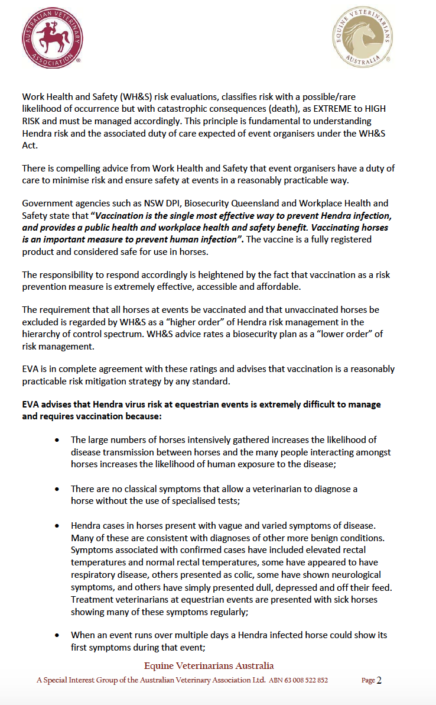

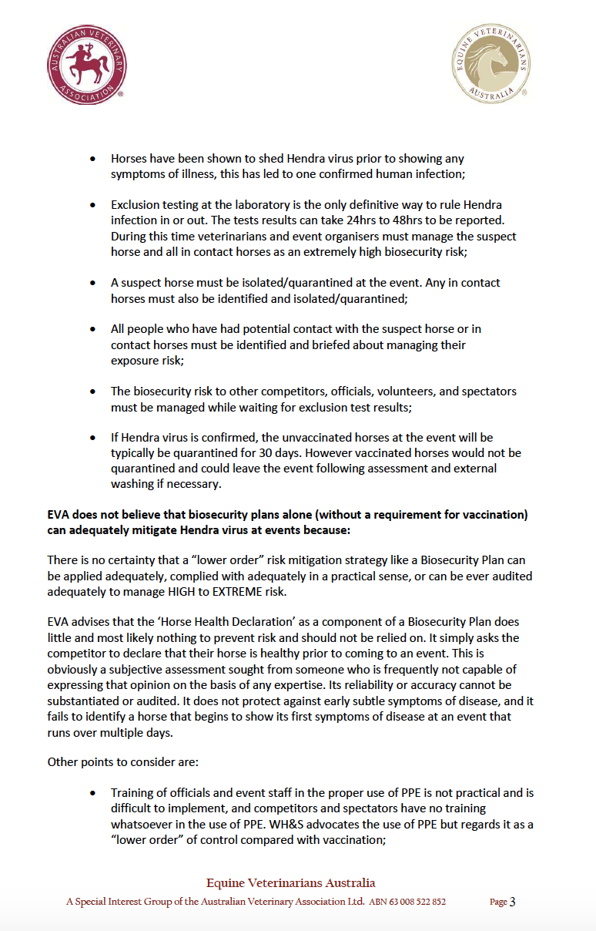

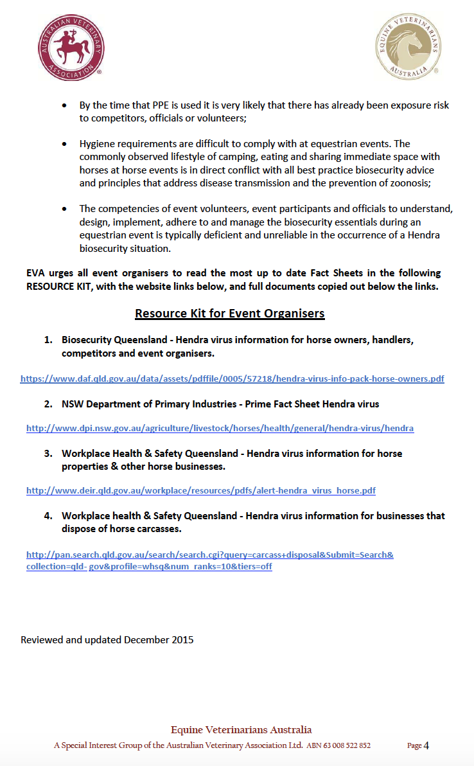

Appendix 1b Hendra and Conjoined Zones by Local Government Area
Hendra Zones
Hendra Zones are defined here as any local government area where there has been a known Hendra incident. The following are the Hendra Zones in Queensland and NSW prepared from the Hendra Virus Incident Summary compiled by the Queensland Department of Agriculture and Fisheries.
QLD NSW
Brisbane City Council Ballina Shire Council
Bundaberg Regional Council Byron Shire Council
Cairns Regional Council Kempsey Shire Council
Charters Towers Lismore City Council
City of Gold Coast Nambucca Shire Council
Douglas Shire Council Tweed Shire Council
Fraser Coast Regional Council
Gladstone Regional Council
Hinchinbrook Shire Council
Livingston Shire Council
Logan City Council
Mackay Regional Council
Mareeba Shire Council
Moreton Bay Regional Council
Noosa Shire Council
Redlands City Council
Rockhampton Regional Council
Scenic Rim Regional Council
Somerset Regional Council
South Burnett Regional Council

Adjoining Zones Queensland Adjoining Zones NSW
Banana Shire Armidale Dumaresq Shire
Barcaldine Regional Bellingen Shire
Burdekin Shire Clarence Valley
Carpentaria Shire Coffs Harbour
Cassowary Coast Regional Hastings Shire
Central Highlands Regional Kyogle Council
Cook Shire Richmond Valley
Etheridge Shire Walcha Shire
Flinders Shire
Goondiwindi Regional
Gympie Regional
Ipswich City
Isaac Regional
Lockyer Valley Regional
North Burnett Regional
North Burnett Regional
Rockhampton Regional
Southern Downs Regional
Sunshine Coast Regional
Tablelands Regional
Toowoomba Regional
Townsville City
Western Downs Regional
Whitsunday Regional

Appendix 2 – 10 Day TQ17 Temperature Log and Horse Health Declaration
For HEV vaccinated horses and horses from non-Hendra risk areas.
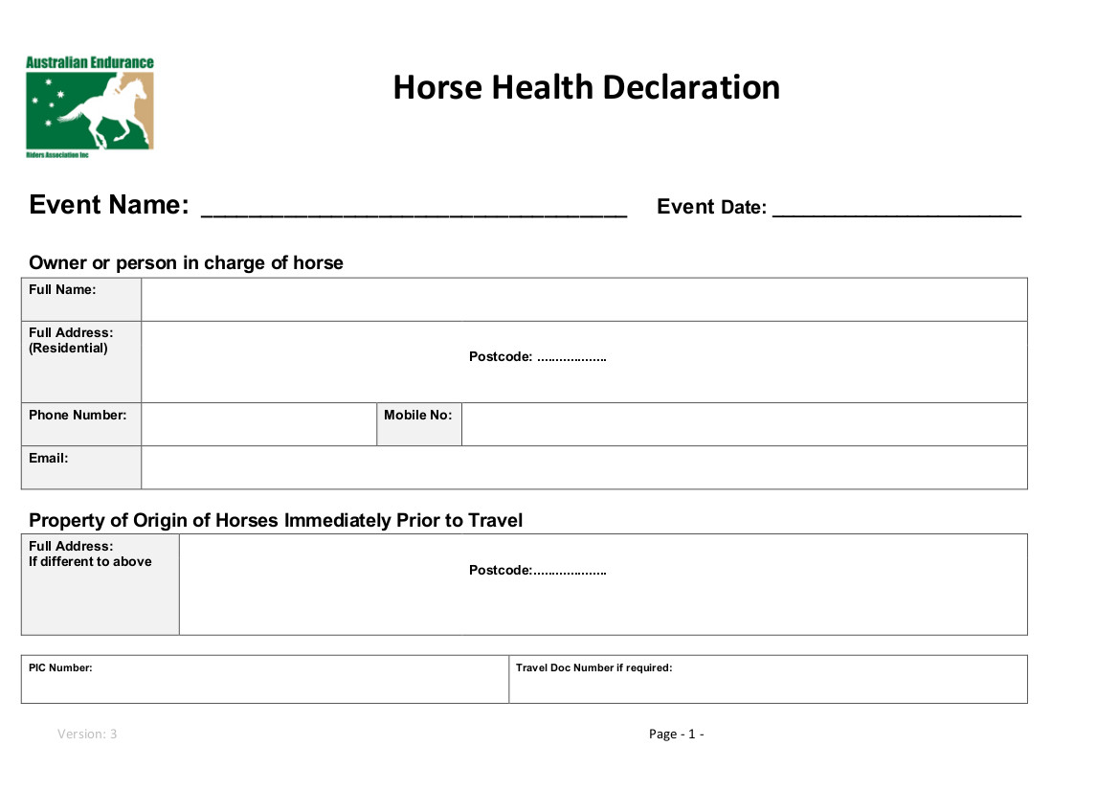
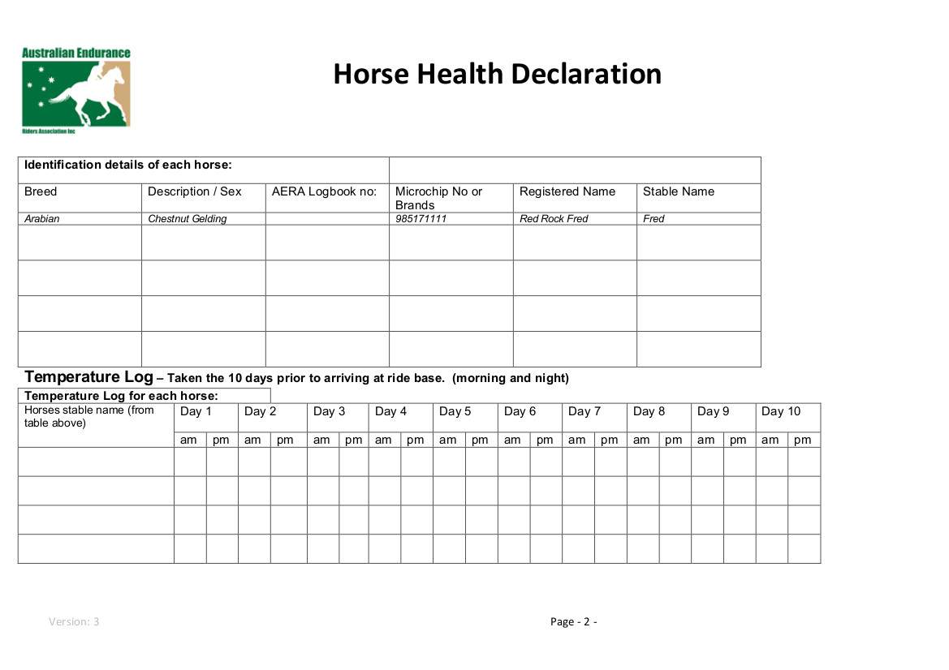
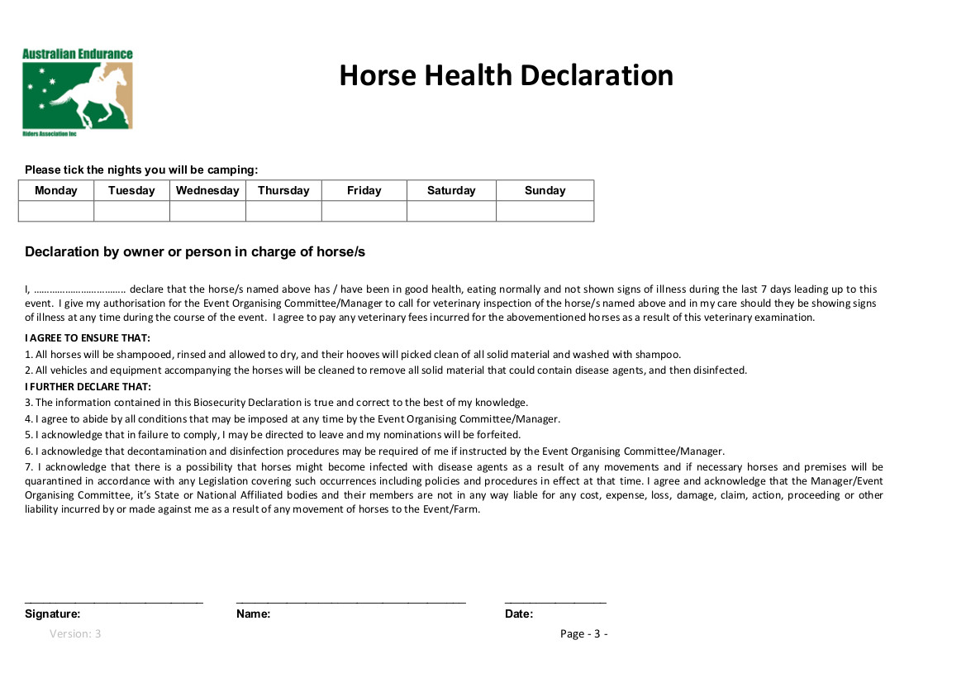

Appendix 3 – 28 day TQ17 Quarantine Temperature Log (one form per horse) page 1
Failure to present a complete temperature Log will prevent entry of this horse to Wirrina Cove ride base for TQ17
Horse name…………………………………………………………………………
Quarantine property address…………………………………………………………………………………………..

Day 1 Day 2 Day 3 Day 4 Day 5 Day 6 Day 7 Day 8 Day 9 Day 10
Date | Date | Date | Date | Date | Date | Date | Date | Date | Date
Temp | Temp | Temp | Temp | Temp | Temp | Temp | Temp | Temp | Temp

Day 11 Day 12 Day 13 Day 14 Day 15 Day 16 Day 17 Day 18 Day 19 Day 20
Date | Date | Date | Date | Date | Date | Date | Date | Date | Date
Temp | Temp | Temp | Temp | Temp | Temp | Temp | Temp | Temp | Temp

Day 21 Day 22 Day 23 Day 24 Day 25 Day 26 Day 27 Day 28
Date | Date | Date | Date | Date | Date | Date | Date
Temp | Temp | Temp | Temp | Temp | Temp | Temp | Temp

TQ17 Travel Temperature Log for Quarantined horses
Record temperature twice daily for every day of travel from quarantine base to ride Base.

Date | Date | Date | Date | Date | Date | Date
am | am | am | am | am | am | am
pm | pm | pm | pm | pm | pm | am

Appendix 3 page 2

Declaration by person responsible for the horse named above.
I …………………………………………………………………………….(print clearly) the person responsible for the horse above, declare that the horse has been in good health, eating normally and has not shown any signs of illness since Monday 5th June 2017. I give permission for the chief steward or his delegate to call for a veterinary inspection of the above horse if it should show any signs of illness whilst at ride Base. I agree to pay any veterinary costs incurred as a result. I further agree that:
- That this horse was shampooed, rinsed, allowed to dry, and hooves picked clean of all solid material prior to departure from the property of quarantine
- That all vehicles and equipment accompanying the horse were in clean condition at the start of travel to TQ17 at Wirrina Cove SA.
- That failure to comply with items 1 and 2 may result in refusal of entry to ride base.
- To be bound by any directions given by AERA chief stewards, veterinarians and event organisers
- That in the event of a horse movement restriction, I agree to be responsible for the care maintenance, feeding and watering of the named horse at my own expense.
I declare the information contained in this document to be true and correct.
Signed…………………………………………………………. Date………………………..

Appendix 4 - TQ17 QUARANTINE DECLARATION incl. declaration of the location
- this document needs to read in conjunction with the full TQ17 Bio Security document and to be completed and received by Committee before 5th of May 2017 and before the Quarantine period is started)

Horse name
Area ID
Horse owner/
Responsible person
Name and phone no.
Property of origin address
P.I.C.

QUARANTINE DETAILS (If at property where another Quilty horse resides, regardless of vaccination status, an exclusion zone of 15m must be maintained for the full 28 days). This includes while feeding, drinking and training.
New address of property
P.I.C.
Property owner
Name and phone no.
Proposed dates of quarantine (min 28 days)
**Nominated Horse may not re-enter a ‘Hendra Zone’ at any time during or after Quarantine period until participation in TQ17 is complete**
TRAVEL DETAILS
Date of proposed travel to SA | (must be after completion of 28 day quarantine)
Date of proposed arrival at SA ride base | (camp boss to be notified if changed)
Name of responsible person while horses are in transit to TQ17 and phone no.
I declare the information above to be true and correct in every particular. False declaration will result in the horse/owner not being admitted to ride base. Post event discovery of subversion of quarantine will result in disqualification from TQ17. As the person responsible for the horse I will allow the TQ17 committee or their delegated representatives to undertake whatever measures needed to confirm the location of the horse during the quarantine period including access to quarantine property if requested.
Signature………………………………………………………………………Date……………………………

Appendix 5 - Site Map

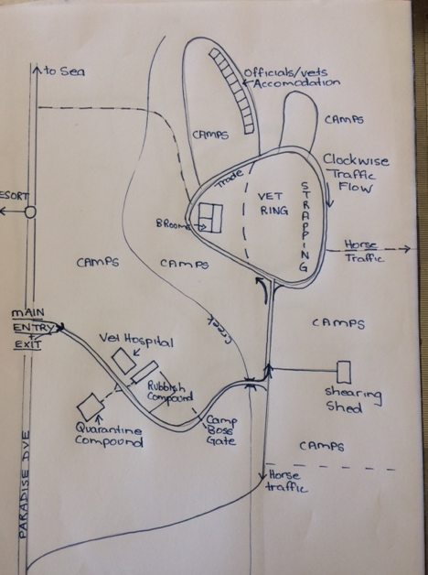

Appendix 6: Emergency Contact List

ORGANISATION | NAME | PHONE  NUMBER | COMMENT
Emergency Animal  Disease Watch Hotline |  | 1800 675 888
Biosecurity SA PIRSA | Animal Services  Emergency Hotline | (08) 8207 7847
Biosecurity Manager | Dr Helen Spencer | 0418995619 | helenspencer4@bigpond.com
TQ2017 Ride Director | Jean Sims | 0429781004 | ina.jean.sims@gmail.com
Head Veterinarian | Dr Lidwien Verdegaal | 0467817839 | LidwienVerdegaal@hotmail.com
Head Chief Steward | Gerard Bou | 0407478929 | gahjpb@hotmail.com
Treatment Veterinarian | Dr Robyn Mather | 0418876848 | robynmather@bigpond.com
Equine referral hospital | Morphetville Equine Clinic  90 Morphett Rd Glengowrie SA 5044 | 08 82948900  horsemedsa.com | Dr Holly Lewis
Venue Owner/Manager | Ben and Holly Taylor | 8598 3125  0419 808 492  0438 427 796 | PIC: SB472288  Number of exit and entry points:  1main of each (3 emergency exit)
Neighbours with horses | Phillip Reid | 0408 856 074 | Next door North of park
Local Police | Normanville Police Station | 8558 2014 | 2 Mary Ave Normanville
Workplace Health Safety  (SA details) | Safe work SA | Help Centre  1300 365 255 | 24/7 emergency  1800 777 209
Ride Base doctor | Andrew Luck
Local hospital | South Coast District Hospital, 56 Bay Rd, Victor Harbour 5211 | 85520500 | 24/7

Appendix 7 – Definitions

Biosecurity Coordinator | person nominated by the Organising Committee
Biosecurity Manager | Person nominated by the ROC to oversee and manage this biosecurity plan.
Chief Steward | The chief steward is responsible for the general control and conduct of the event from the opening of the ride base until the closure of the ride base. Further details of responsibility is listed in the AERA rulebook (2016).
Communal water trough | Large trough of water that will be accessed by multiple horses. A communal water trough may or may not be used at an event, but if in use, water should be bucketed from the trough, horses should not drink directly from the trough.
Hendra Risk Area | Local government areas identified by Queensland and NSW state governments.
HEV | Vaccination available to horses to prevent Hendra Virus Infection
PPE – Personal Protective Equipment | refers to protective clothing, helmets, goggles, or other garments or equipment designed to protect the wearer's body from injury or infection.
Property Identification Code (PIC) | An eight character code allocated by a Victorian DELWP, or the equivalent authority in other states/territories, to identify a livestock producing property.  The National Livestock Identification System (NLIS) is Australia's system for the permanent identification and tracing of livestock for market access, food safety and disease control purposes.
Responsible person | The person responsible for the horse at a ride is prima facie, the rider and the trainer of the horse, (jointly and severally), however support personnel and the owner of the horse may also be regarded as additional persons responsible if they were present at the event and/or made a relevant decision about the horse, and compelling circumstances warrant such an extension.as defined by the AERA rulebook (2016) is the nominated rider of the horse in the event.
Ride Organiser | The nominated spokesperson of an Incorporated Entity which is formally affiliated with the AERA or a State to conduct an event in accordance with the AERA Rulebook.
Ride Organising Committee (ROC) | An incorporated entity which is formally affiliated with the AERA or a Division Association to conduct the Tom Quilty Gold Cup in accordance with the AERA Rulebook.
Ride Venue | The nominated address for this document – associated with the Tom Quilty Gold Cup

